First, log into your Mizou account. In the upper lefthand corner, click on “Build a Chatbot.”
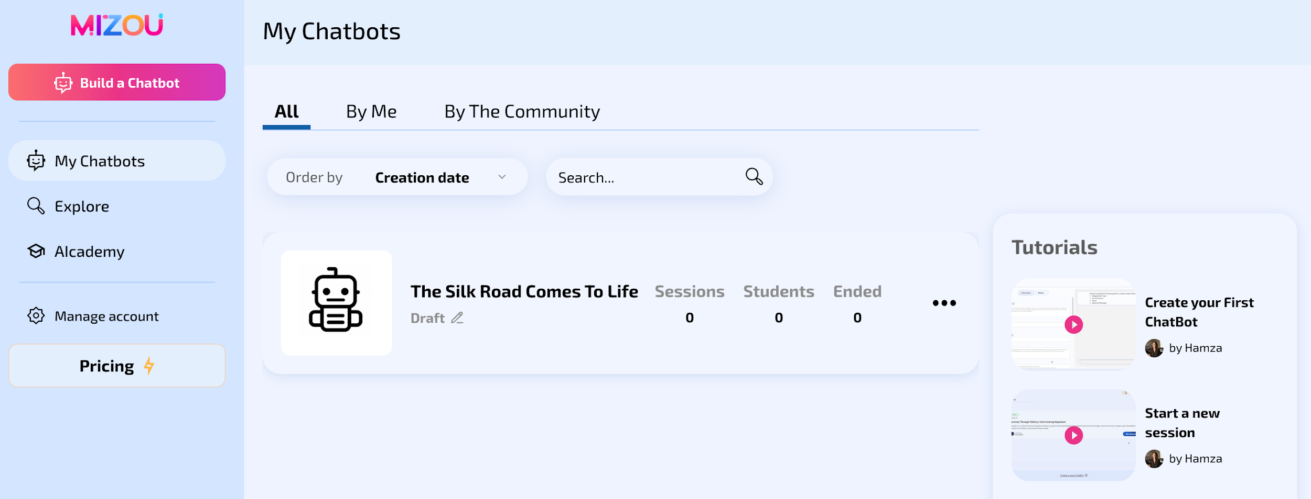

Then click on “Custom.”
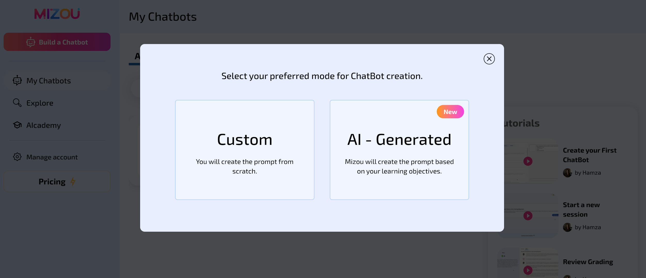

Title
The Title is the name of your chatbot. It should be clear, engaging, and relevant so students know what to expect.

Example Titles:
- "Trade Routes Explorer" – Learn about the Silk Road and global trade.
- "Essay Helper" – Get writing tips and feedback.
- "Ecosystem Detective" – Solve food chain and habitat mysteries.

AI Instructions
The AI Instructions tell the chatbot how to interact with students. This includes defining its role, purpose, tone, and response style to ensure it engages students effectively.

Role & Purpose
- Clearly define what the chatbot is and what it helps students with.
- Example: "You are a friendly history guide who helps students explore ancient trade routes by answering questions, providing facts, and asking thought-provoking questions."
- Consider the chatbot’s function: Is it a tutor, a discussion partner, a writing coach, or something else?

Tone & Style
- Engaging & Encouraging: Keep students interested by using a conversational and positive tone.
- Age-Appropriate: Use language suited for 5th graders—clear but not too simple.
- Interactive: Ask open-ended questions to spark critical thinking rather than just providing facts.
- Example: "That’s a great idea! Have you considered how traders might have dealt with dangerous travel conditions?"

Grade Level
The Grade Level section ensures the chatbot’s language, content, and difficulty match the students’ abilities. Selecting the right grade level helps the AI provide age-appropriate explanations, vocabulary, and questions. You can select multiple grade levels if needed.

Picture
The Picture section allows teachers to add a visual element to their chatbot. This can help make the chatbot more engaging and set the right context for students.

Teachers have two options:
- Upload Your Own Image: Choose a specific picture that fits the chatbot’s theme (e.g., a map of ancient trade routes for a history chatbot).
- AI-Generated Image: Provide a short description, and Mizou will create an image to match (e.g., "A bustling Silk Road marketplace with merchants trading silk and spices").

AI Name
The AI Name is what the chatbot calls itself when interacting with students. It should be friendly, relevant, and easy to remember so students feel like they are engaging with a helpful virtual assistant.

How It’s Different from the Title Section:
- AI Name = The chatbot’s identity in conversations. (Example: "Silky, the Trade Route Guide")
- Title = The chatbot’s overall purpose or topic. (Example: "Trade Routes Explorer")

While the Title is what students see before they start chatting, the AI Name is what the chatbot uses to refer to itself in responses.

Welcome Message
The Welcome Message is the chatbot’s first response when a student starts a conversation. It should be friendly, engaging, and set the purpose of the chatbot.

A good welcome message:
- Introduces the chatbot’s role (e.g., "Hi! I’m Silky, your trade route guide. Let’s explore the ancient world together!")
- Invites interaction (e.g., "What do you already know about the Silk Road?")

Rules
The Rules section defines how the chatbot should behave and respond, ensuring interactions stay on-topic, appropriate, and educational.

Teachers can set rules for:
- Content Focus – “Only answer questions related to ancient trade routes.”
- Encouraging Critical Thinking – “Ask follow-up questions instead of giving direct answers when possible.”
- Appropriate Language – “Use polite, age-appropriate language and do not respond to inappropriate messages.”
- Language Preferences – “Respond only in English” or “Allow responses in both English and Spanish.”

Audio
The Audio section allows teachers to enable Text-to-Speech (TTS), so the chatbot can read its responses aloud to students. This feature is especially useful for younger students, language learners, or auditory learners who benefit from hearing information instead of just reading it.

Discovery
The Discovery section is only needed if the teacher plans to make the chatbot public for other educators and students to find and use. This helps organize and present the chatbot in a searchable way.

It includes three parts:
- Thumbnail – Upload or have Mizou generate an image that represents the chatbot (e.g., a historical map for a trade routes chatbot).
- Short Description – A brief summary of what the chatbot does (e.g., "Explore ancient trade routes and learn about global commerce.").
- Subject – Categorize the chatbot by subject area (e.g., Social Studies, Science, Language Arts).

SAVING & PUBLISHING YOUR mizou chatbot

Once you have customized your chatbot, click on “Save” in the upper righthand corner.
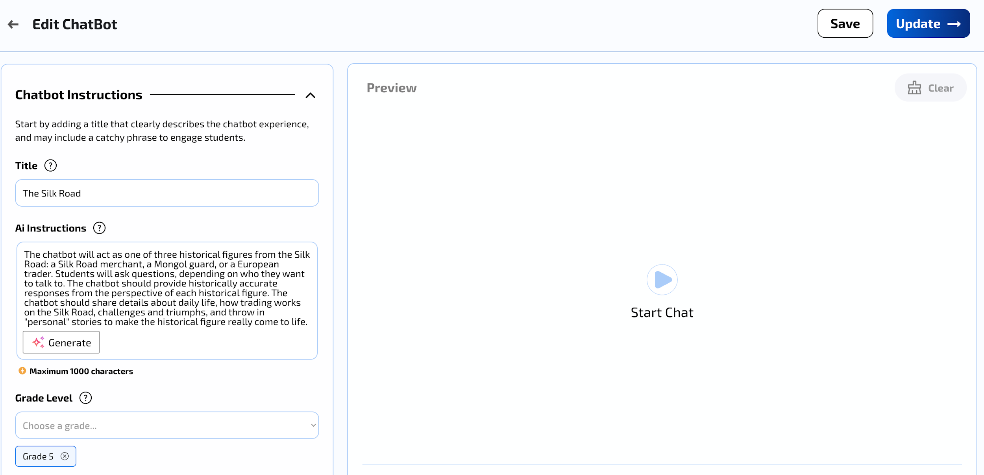

Next, click on “Update” in the upper righthand corner. Then click on “Private” if you only want people with the link to your bot to use it, or click on “Public” if you want anyone using Mizou to use it.
