First, log into your School.ai account. Then, click on “Create a Space.”
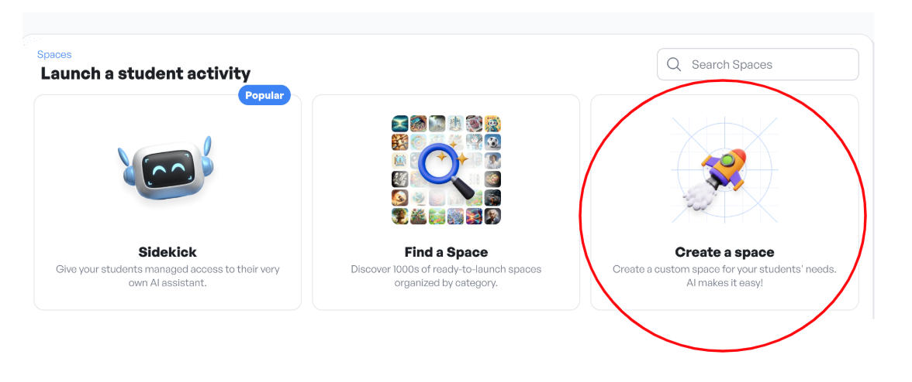

Title
The Title is the name of your chatbot. It should be clear, engaging, and relevant so students know what to expect.
Example Titles:
- "Trade Routes Explorer" – Learn about the Silk Road and global trade.
- "Essay Helper" – Get writing tips and feedback.
- "Ecosystem Detective" – Solve food chain and habitat mysteries.

Ai Prompt
The AI Prompt tell the chatbot how to interact with students. This includes defining its role, purpose, tone, and response style to ensure it engages students effectively.
Role & Purpose
- Clearly define what the chatbot is and what it helps students with.
- Example: "You are a friendly history guide who helps students explore ancient trade routes by answering questions, providing facts, and asking thought-provoking questions."
- Consider the chatbot’s function: Is it a tutor, a discussion partner, a writing coach, or something else?
Tone & Style
- Engaging & Encouraging: Keep students interested by using a conversational and positive tone.
- Age-Appropriate: Use language suited for 5th graders—clear but not too simple.
- Interactive: Ask open-ended questions to spark critical thinking rather than just providing facts.
- Example: "That’s a great idea! Have you considered how traders might have dealt with dangerous travel conditions?"

Standards
The AI Prompt tells the chatbot which academic standards and grade level to adhere to. Right now, this is strictly Common Core Standards, but it is noted that more will be added soon.

Add files
Adding files to your chatbot on School.ai allows it to reference specific materials, such as syllabi, lesson plans, or instructional guides, ensuring more accurate and context-aware responses. This helps personalize interactions for students.

Cover image
The cover image section allows teachers to add a visual element to their chatbot. This can help make the chatbot more engaging and set the right context for students.
Teachers have two options:
- Upload Your Own Image: Choose a specific picture that fits the chatbot’s theme (e.g., a map of ancient trade routes for a history chatbot).
- AI-Generated Image: Provide a short description, and School.ai will create an image to match (e.g., "A bustling Silk Road marketplace with merchants trading silk and spices").

Subtitle
The subtitle in School.ai provides a brief, secondary description of your chatbot’s purpose. It appears below the chatbot’s name and gives users quick insight into its role.
- For example, if your chatbot helps students with math, its subtitle might be: "Your AI-powered tutor for step-by-step math guidance!"

Teacher description
Even though the chatbot is for students, the teacher description explains its function from an educator’s perspective. This might be useful for teachers to understand how the chatbot aligns with their instruction, and how they might use it if you set it to public.
- Example: “This chatbot helps students practice proportional reasoning by breaking down problems, providing hints, and offering real-world examples.”

Student description
The student description is the most important for your use case. It tells students how they can interact with the chatbot and what it can help them with.
- Example: “Ask me about proportional relationships! I can help explain unit rates, guide you through solving problems, and check your answers.” This setup ensures students know exactly how the chatbot can support their learning.

SAVING & PUBLISHING YOUR School.ai chatbot

Once you have customized your chatbot, click on “Save & Launch” in the upper righthand corner.
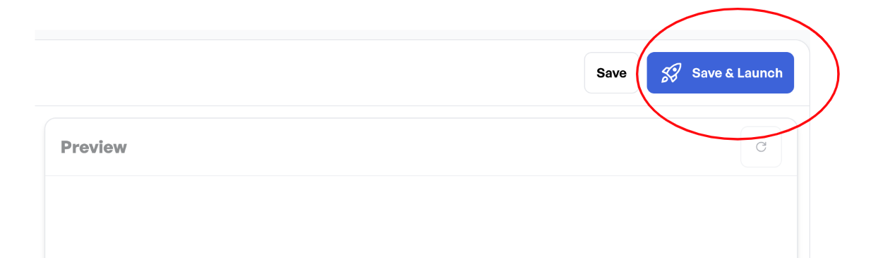

Next, you will have an option of inviting your students to the chatbot via Google Classroom or a QR code.
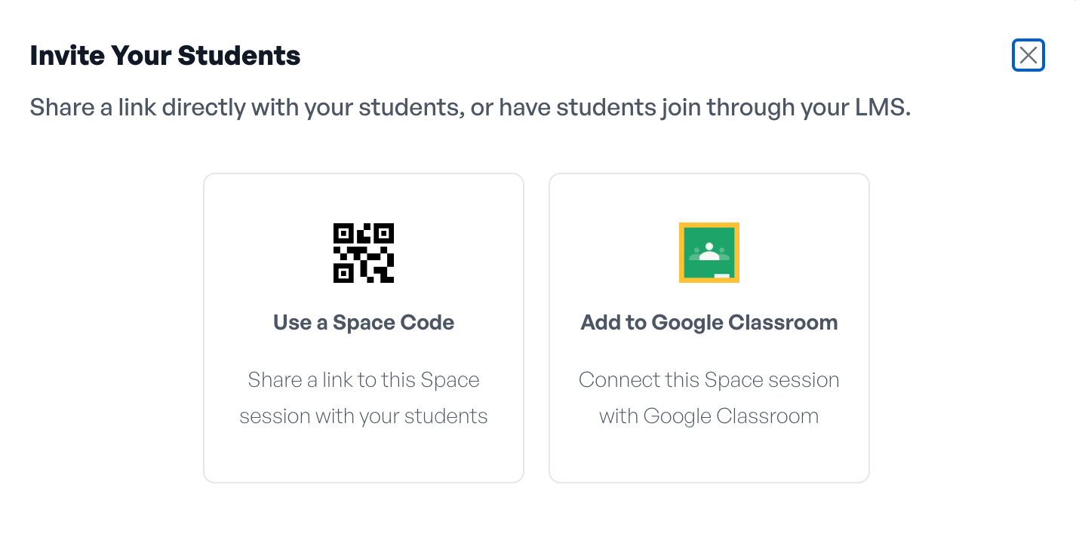

If you only want people with the link to your bot to use it, click on “Private.” If you want anyone with School.ai to have access to the bot, click on “Public.”
